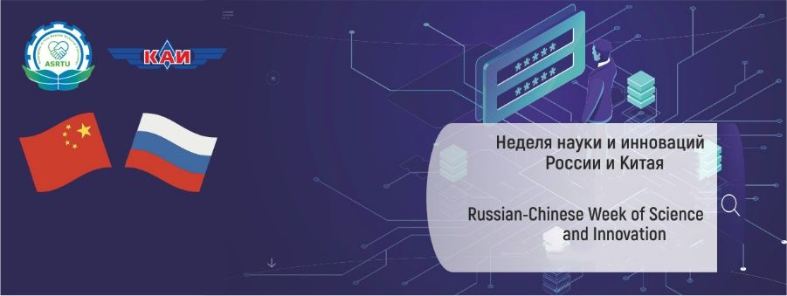

Contacts Persons for sending Abstracts

EVENT NAME | Contact Person
Sino-Russian Symposium & Forum of Young Scientists on Materials Science and Processing Technology | Dr. Alexey Belyaev  E-mail: avbelyaev@kai.ru
Conference on Quantum Technology | Prof. Sergey A. Moiseev  E-mail: samoi@yandex.ru
Second Sino-Russian Forum on Helicopter Technology | Dr. Andrey Batrakov  E-mail: asbatrakov@kai.ru
FORUM “Engineering Education of the Future: A New Paradigm” | Dr. Ekaterina Zagrebina  E-mail: EIZagrebina@kai.ru

